Realising the statistical potential of administrative data on air passenger traffic

O’Hanlon, Niall
Central Statistics Office,
Skehard Road,
Cork,
Ireland.
niall.ohanlon@cso.ie

Disclaimer
Any of the views expressed are those of the author and do not reflect the views or policies of the Central Statistics Office.

1. Introduction

During 2005 the Central Statistics Office (CSO) redeveloped its Country of Residence Survey (CRS) to produce a set of rapid indicators for inbound tourism to Ireland. Fundamental to this redevelopment was the use of administrative data on air passenger traffic at airport to airport level to weight the CRS survey results. The CSO appreciated that a central dissemination resource for this administrative data would be of benefit to the tourism industry and beyond and saw this as an opportunity to provide a new statistical output at relatively little cost.

In early 2008 the Airport Pairings database was launched on the CSO website. The CSO recognises in it the potential to link aviation and tourism statistics together, with benefits for tourism and environmental statistics in particular.

This paper will discuss the genesis of the Airport Pairings database in the redesign of the CRS. The use of this database within the CRS and the improvements resulting will be explained. The paper will then introduce the Airport Pairings database demonstrating the functionality afforded to the user. Feedback from data providers and users will be discussed. A planned new version of the dataset with an additional variable covering passenger country of residence will be examined. Other potential uses of the dataset will be explored with specific reference to the production of more detailed tourism statistics and environmental statistics in respect of the emissions attributable to air passengers.

2. The Country of Residence Survey 1981 - 2004

The CSO’s Country of Residence Survey (CRS) was introduced in January 1981, with the objective of producing robust annual estimates for resident and non-resident passenger breakdowns on all air and sea routes into and out of Ireland. The results of the CRS were applied to those of the Passenger Card Inquiry (PCI), another continuous frontier survey collecting such variables as reason for travel, length of stay and expenditure. In the CRS country of residence was captured according to 19 countries or country groupings based on the principal tourist origin countries at the time. However the level of published detail was aggregated to 5 groups with matched Balance of Payment requirements at that time.

The 1981 sample was conducted at the 3 principal airports and 4 sea ports which between them accounted for almost all overseas travel. It was designed as a 1% sample survey with approximately 55,000 passengers surveyed across 44 strata from a total of 6 million journeys. The stratification was devised so that it would produce separate estimates for each air and sea port and yield a high degree of precision by dividing the travelling population into more homogeneous sub-populations. Survey results were compiled into their respective strata and then weighted to the corresponding population totals.

With respect to air travel, stratification was organised on the basis of Irish Airport, scheduled/chartered flights, Irish/foreign carrier and route. Routing was aggregated into 3 groups; Cross Channel (i.e. to/from Great Britain), Continental European and North American (see Figure 1). These strata reflected the air travel patterns of the time.

Figure 1. – CRS (air travel) Stratification

The airports initially provided the passenger numbers for each of the sub-populations. However these aggregation cells had to be specially compiled by airport authorities, as they were not naturally utilised or occurring within the industry. As the tourism and travel industry developed and a greater number of routes, airlines, baggage handlers and booking methods were established, the quality of the estimates provided by the airport authorities became increasingly uncertain. By 2004 the sample had grown to 585,000 passengers covering 24 million journeys. Calculating sub-populations for the air strata had become so problematic for the larger airport authorities that they stopped estimating them. Instead they began sending passenger movement numbers at differing levels of aggregation to the CSO where considerable time and effort was then spent trying to recreate the strata totals required for weighting.

By this time it had also become obvious that the air travel strata designed in 1981 were decreasingly homogenous and did not reflect emerging travel patterns. The dramatic increase in the number of carriers and routes and the use of regional airports also raised serious questions within CSO and the industry about the accuracy and relevance of data published from the CRS. Increasingly frequent requests for more detailed non-resident data from Balance of Payments, the tourism industry and other data users went unanswered, as the survey wasn’t designed to deliver robust detail beyond highly aggregated data. Over-sampling of particular routes within strata was a growing source of sample error and also made it difficult to provide the level of detail on country of residence that the industry required. Given such problems with the collection, processing and use of different levels of passenger movement data and the requirements for more detailed outputs, a complete redesign of the CRS was necessary.

3. The redesigned CRS

Discussions with the various airport authorities in early 2005 revealed that their preference was to supply monthly passenger movement data to the CSO on a more disaggregated level, in the form of airport pairings i.e. the total number of passengers embarking and disembarking on every airport to airport route. Each of the airport authorities already had these data compiled for administrative purposes and so they were no longer required to perform any aggregation, adjustment or manipulation prior to transmission. Consequently data could be received much faster – over a month earlier in some cases. Although the airports were transmitting more detailed and useable passenger data with a reduced time lag, their response burden was significantly reduced. All nine of the Irish airports readily agreed to provide this increased level of detail to the CSO.

Sub-populations based on airport to airport pairings represent highly homogenous stratification groups. Passenger traffic through airports in the same country can present varied characteristics depending on regional location, and is typically influenced by factors such as proximity to cities, holiday resorts or other amenities. However airports separated by the shortest of distances can also display vastly differing passenger profiles if one of these airports is an international (or even a “low cost”) hub. Importantly, the effect of over-sampling on an airport to airport pairing stratum does not impact on survey quality beyond the inefficient use of resources. It was clear therefore to the CSO that airport pairings presented the best solution for the creation of new strata both in terms of the availability of the administrative data required and the vastly improved level of homogeneity accruing.

Irish Airports display flight data using IATA airport codes. Therefore utilising these codes in the CRS allows for a standardised coding process from survey data capture through processing and on to dissemination. This also allows data linking to other administrative datasets. In addition the redesigned survey has moved away from capturing country groupings and instead captures country level detail i.e. travellers are now being coded to individual countries of residence rather than country groupings, affording much greater flexibility in respect of detailed dissemination.

Weighting of survey returns to airport pairing totals is also relatively straightforward. Returns for each airport pairing in a month are totalled and then weighted to the administrative passenger totals on the corresponding route. Where there is no survey coverage on a route in a particular month values are imputed using 1 of 8 nearest neighbour conditions. During 2007 the CRS was conducted at 5 of the busiest of the country’s 9 airports (there are plans to extend the survey to the remaining 4 airports). The sample size of the survey in 2007 survey was just over 612,000 passengers from 31 million journeys. An analysis of survey data from December 2007 shows there were 335 different overseas air routes comprising of scheduled, chartered and private flights. Over 92% of total air passenger movement was accounted for by the 145 routes sampled. Most of the unsampled routes were imputed using nearest neighbour conditions and manual estimates were applied for the remainder.

The redesigned CRS allows for the production of far greater detail than its predecessor. Estimates for passengers travelling from any country of residence on any route or combination or routes are easily extracted. A comprehensive set of statistics is now published approximately 6 weeks after the end of each reference period. The monthly “Overseas Travel” report disseminates inbound traveller estimates for 26 individual countries and 8 residual country groupings. Crucially, the redesigned survey operates at no extra cost to the CSO and places a reduced burden on data providers by utilising existing administrative data.

4. The Airport Pairings Database

During the initial discussions with some of the airport authorities regarding the transmission of their passenger numbers by airport pairing data it became apparent that a central dissemination resource for this data would be of enormous benefit to the industry and beyond. The usefulness to the air travel industry in Ireland of data published by the Civil Aviation Authority in England, in the absence of an equivalent Irish resource, was singled out as an example. The industry therefore encouraged the creation of such a resource. The CSO saw this as an opportunity to provide a new statistical output, an airport pairings database, at relatively little cost. Several of the airports insisted that data should only be published after a 6 months delay so as to protect any market sensitivities that might emerge. The CSO conceded to this, as it was anxious to retain support for the project from our data providers.

To meet identified requirements, and to provide a system that could cater for those unanticipated needs, the CSO considered that passenger movement detail should be published at the lowest level of route – airport to airport pairings. Residuals should only occur where routes are not known beyond country detail or where origin/destination airports are not IATA coded, thus preserving the integrity of the data. The Airport Pairings database, which is disseminated on the CSO Webster via PC-Axis, contains a matrix of 9 Irish airports by over 500 foreign airports, resulting in almost 5,000 data cells per month. Since March of this year it is published on the CSO’s online database (Database Direct) allowing users to navigate or search for relevant datasets/data tables, subset and restructure them before viewing on screen or saving to a file type of their choice. The combination of completeness and integrity of data with the functionality of a powerful dissemination tool ensures its appeal to a very broad spectrum of user, ranging from students to professional industry researchers. The database allows 3 different levels of search or aggregation namely Airport, City and Country. The screenshots below demonstrate how the user can search the database. In this example Dublin has been selected as the Irish airport. The selection for partner airports is the result of a search for Norwegian airports. Inward and outward flights during the month of June 2007 have been selected. The resultant output shows passenger traffic between Dublin and 4 Norwegian airports.

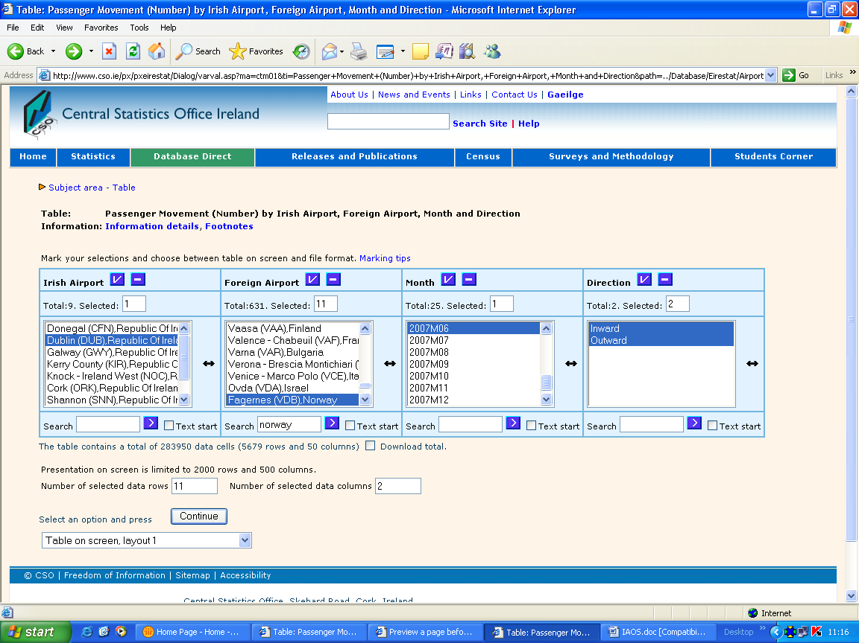

Figure 2. – Screenshot of Airport Pairings Database selection page on CSO website

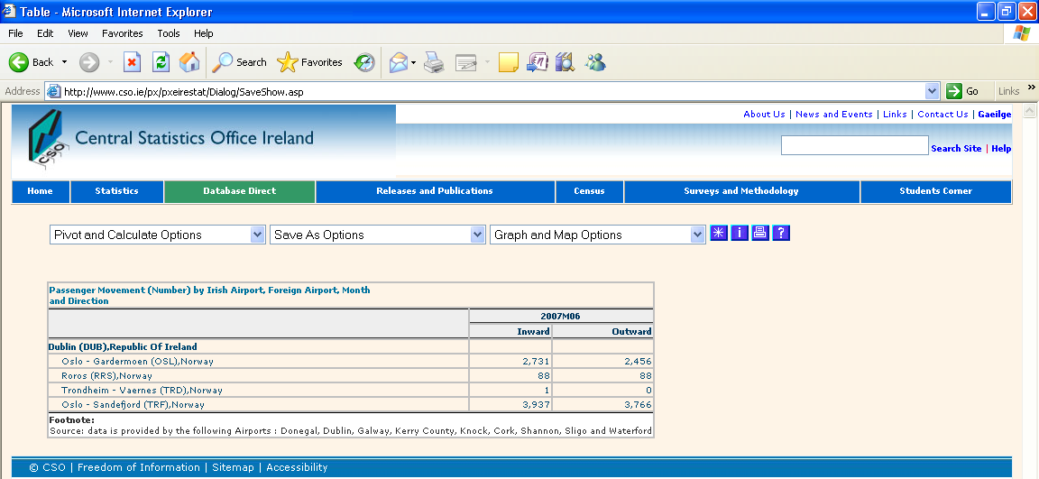

Figure 3. – Screenshot of Airport-Airport Database output

5. Balancing user needs with dissemination costs

When the Airport Pairings database was launched the CSO invited feedback from each of the data providers, the principal Irish airlines and also some members of the public who had sought this type of detail in the past. Feedback was both positive and detailed, which suggested to us that these users were interrogating the data very closely. A number of common suggestions for improvement emerged. The 6 month delay in publishing data was flagged a number of times as a weakness and the CSO is currently working towards securing permission from data providers to cut this to weeks rather than months. There is also a strong demand to extend the dataset to domestic routes and Northern Irish routes. The limitation to overseas traffic only is an obvious example of where the scope of the dataset is constrained by it origins, that is in providing a grossing frame for the overseas travel orientated CRS. However this demand may ultimately prove to be a positive as an improvement to the dataset in this regard could provide an impetus for broadening the scope of the CRS. Conversely the requirement to select data by direction (into or out of the country), a fundamentally important disaggregation for the CRS and other tourism statistics, is viewed as at best an inconvenience among some industry users. There were also some suggestions for more user-friendly presentation of the data such as suppression of zero value cells and minimum passenger threshold options. While the CSO recognises that such refinements might make the database more user-friendly, they must be balanced against the associated development costs. At this time any additional development costs will be focused towards expanding the scope or content of the database.

6. Planned additions

The CSO has developed a CRS database, for internal analysis, that estimates the country of residence splits for individual airport pairing routes. This is effectively an extension of the airport pairings database, allowing it to be analysed using the same metadata. The ability to analyse survey data by specific country of residence and airport pairing, or both, is an important improvement. A process for generating accuracy indicators for country of residence estimates on each airport pairing route (or even combination of routes) is currently being developed. It is envisaged that these developments will in the future result in a publicly disseminated database showing estimates for passenger country of residence splits (and associated accuracy indicators).

The CSO has designed a new inbound visitor interview, based on the UN-WTO model for border surveys. It is expected that this survey will be implemented in the coming months. It will capture data on reason for journey, additional activities, regions visited, accommodation used, trip frequency, booking method, pre-trip and trip expenditure broken down by type. There will also be supplementary questions on travel in Northern Ireland. This survey will be weighted to the results of the CRS at airport to airport pairings level. There will, therefore, be a direct link between visitor behaviour and specific route of travel. In fact it will be relatively simple to link unit level traveller data using IATA codes to the route data provided by the airport authorities. Detailed data on tourist behaviour will have a precise routing dimension. It is expected that results will be disseminated in a similar format to the Airport Pairings although at an aggregated level.

The airport pairings database already provides invaluable data on the growth or decline of traffic and route volumes through regional airports in Ireland. When allied to detailed visitor behaviour data available from the frontier tourism surveys it will also facilitate greater analysis of the contributions of different passenger categories, as well as airport and airlines to the regional economies. The ability to examine the profile, behaviour and contribution of travellers to Ireland on non-direct routes will also be of great importance.

7. The potential for linking with other administrative data

As noted earlier, the initial impetus to develop the airport pairings database emerged indirectly from the development of tourism statistics. As a result, IATA airport codes, which are used for passenger transport, were deliberately used facilitating a direct link to the CRS data. However interest in air passenger traffic volumes has an audience beyond tourism. In particular the crossover or overlap with aviation transport statistics is substantial.

The linking of the databases previously examined to ICAO airport codes (which are more typically used in transport statistics) could magnify the potential of the airport pairings database considerably. With environmental sustainability quickly emerging as an important issue, particularly for tourism which relies so heavily on transport (a sector generally viewed as a heavy polluter), the airport pairings database offers rich potential. At present estimates for emissions from air travel are predominately calculated using a ”top-down” approach. For example, in the case of Ireland, estimates are derived from the quantity of aviation fuel sold in the country. Such an approach greatly limits analysis, as the total emissions cannot be disaggregated into route or traveller type. This problem is of course not just confined to Ireland. In 2006 the European Commission conducted an impact assessment on the inclusion of aviation in the EU Greenhouse Gas Emissions Trading Scheme. The analysis of the effect on tourism was based, in the absence of EU-wide data on air traveller emissions, on data generated from the TEN-STAC model, which is primarily focused on land-bound inter-regional traffic flows.

Further development of the Airport Pairings database could offer an alternative to the “top-down” approach. Capacity (load factor) or utilisation analysis could be conducted by linking airport pairings data to data being compiled under EU Regulation 437/2003. Currently the database provides passenger traffic by route. Simply adding the actual distance travelled (KM) for each of these routes, calculated using “Great Circle” distances that are readily available, will allow an analysis of passenger-KM generated by passenger traffic in and out of Ireland. If the passenger movement data provided by the airports was further broken down by aircraft type then data on aircraft emissions (published by the European Environment Agency) could be applied to it. This would allow for examination of emissions by route and per passenger. Applying such emissions data to the CRS database could give estimates for emissions by country of residence. In the same way applying them to the database on visitor behaviour would enable a cost benefit analysis of emissions against revenue generated by air travellers.

8. Conclusion

The CRS redesign resulted in significant changes to both its methodology and production cycle and has yielded more robust estimates and a new set of rapid indicators. Central to this redesign was the more efficient use of administrative data. Crucially this has been a positive experience for all parties concerned. From a CSO perspective we get highly disaggregated data affording a range of improvements such as better sampling schemes, imputation methodology and greater flexibility and timeliness of dissemination. From the perspective of the airport authorities, despite the greater level of detail provided, the data are easier and faster to compile and consequently the burden to them has reduced. Their confidence in the CRS has increased as the strata used in the CRS now matches industry data.

The improved use of administrative data has also yielded an entirely new database with potential far beyond the CRS. The dissemination of the Airport Pairings database has been very well received by data providers and users. By linking it back to data CSO tourism surveys it can also provide very detailed estimates on the country of residence of air travellers and on their behaviour. Furthermore, matching IATA to ICAO codes will allow for further applications of the database. In particular, securing some additional administrative data from airport authorities would allow the CSO to link the Airport Pairings database (and detailed data on traveller behaviour) to the European Environment Agency’s emissions database.

References

EMEP/CORINAIR Atmospheric Emission Inventory Guidebook, Third Edition. Copenhagen: European Environment Agency, 2007

European Commission Staff Working Document, Summary of the Impact Assessment: Inclusion of Aviation in the EU Greenhouse Gas Emissions Trading Scheme (EU ETS), 2006

Eurostat (2003), Regulation (EC) No 437/2003 of the European Parliament and of the Council of 27 February 2003 on statistical returns in respect of the carriage of passengers, freight and mail by air, L 66/1 Official Journal of the European Union 11.3.2003.

ICAO (2007), Aircraft Type Designators, Document 8643, Edition 35, ICAO website.

Walter Anthony Kehoe, “Managing Aviation Emissions – from Measurement to Policy’ (MEngSc thesis, National University Cork)

IATA – International Air Transport Association
ICAO – International Civil Aviation Organisation
Walter Anthony Kehoe, “Managing Aviation Emissions – from Measurement to Policy’ (MEngSc thesis, National University Cork)
'EMEP/CORINAIR Atmospheric Emission Inventory Guidebook, Third Edition. Copenhagen: European Environment Agency, 2007'

